**USE GUIDE**

1. **Client**

Features:

1. **Find Doctor**

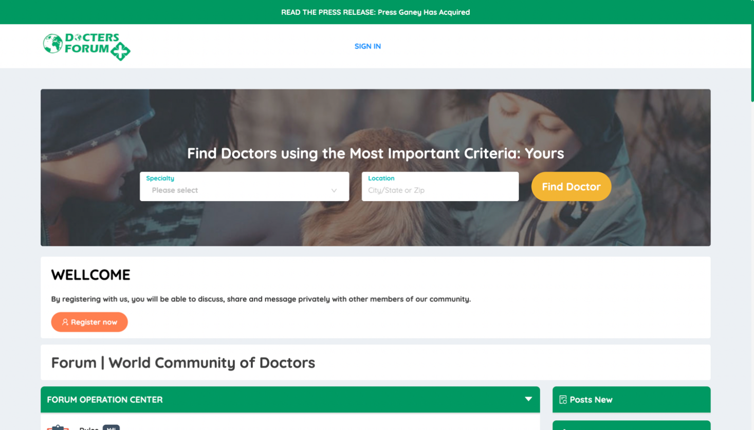

Search for doctors by specialty, location.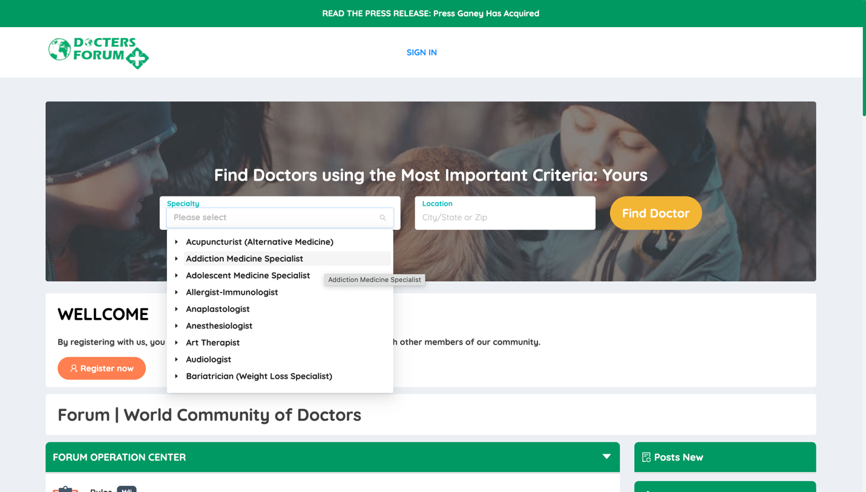

When submitting "Find Doctor" and no results are found, the interface will display:

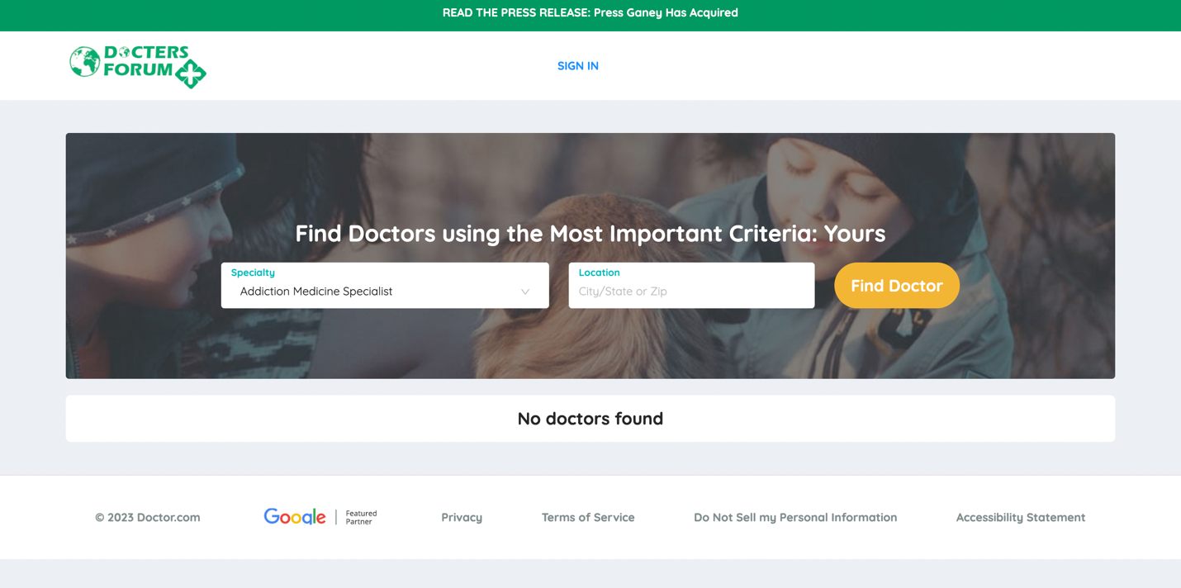

This is the interface when a doctor is found

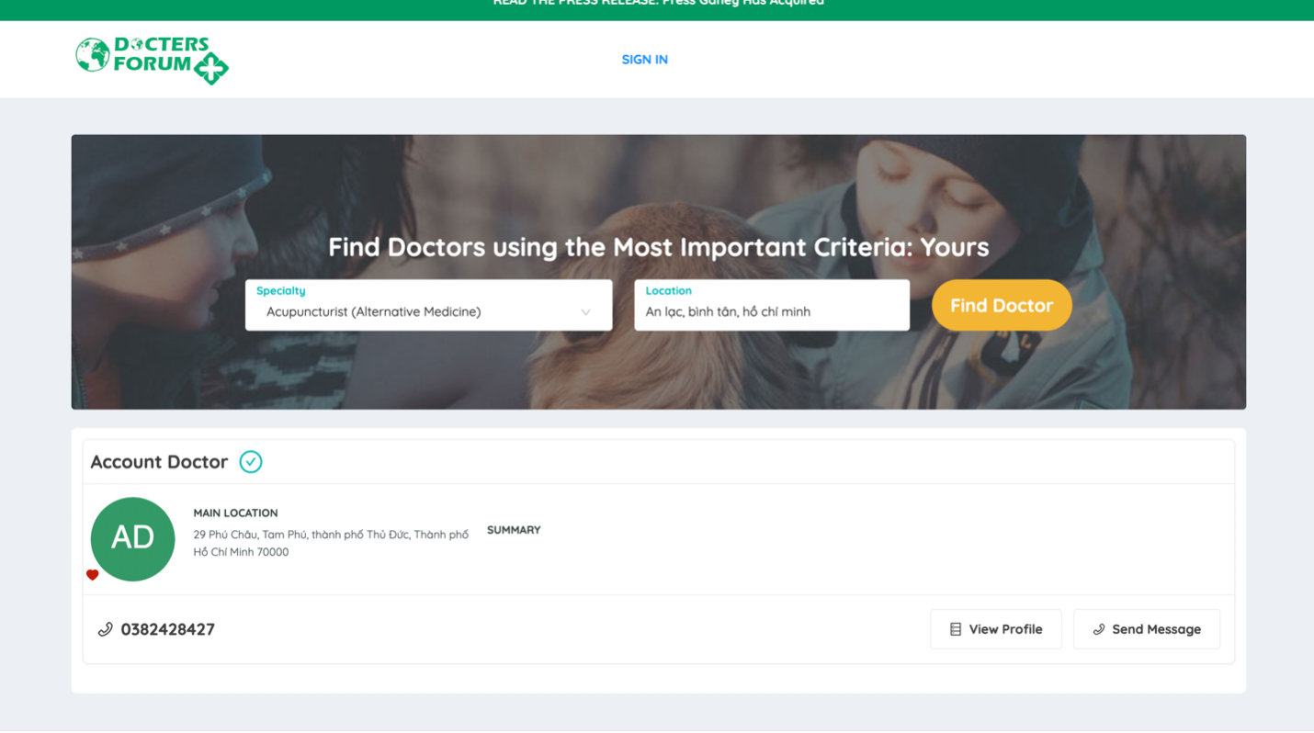

Doctor's detailed information

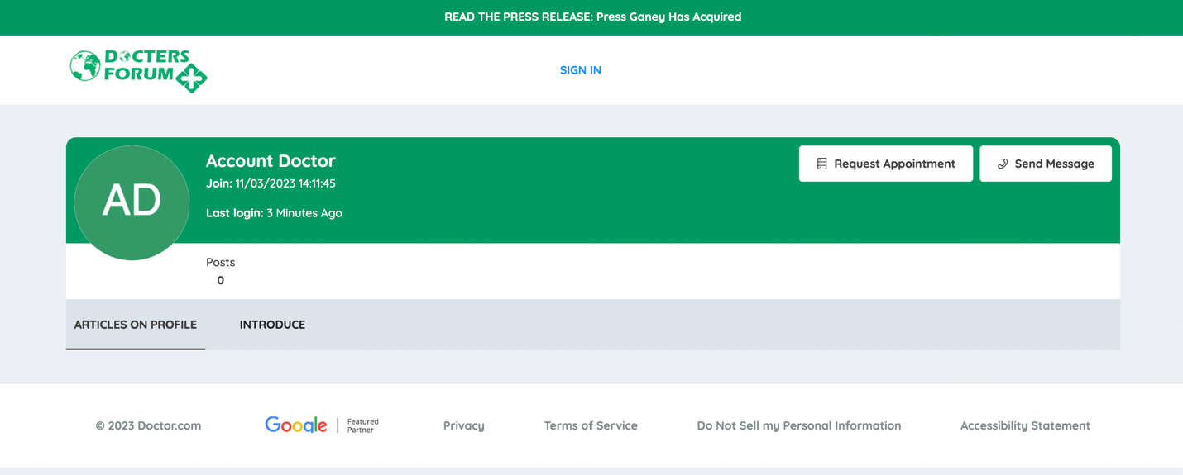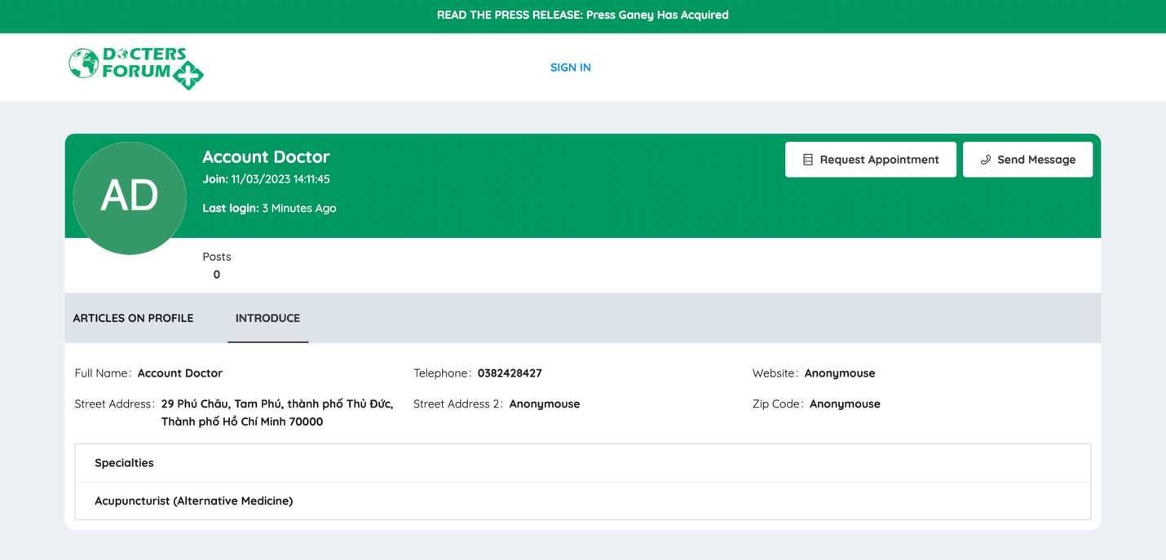

Create an appointment request with the doctor.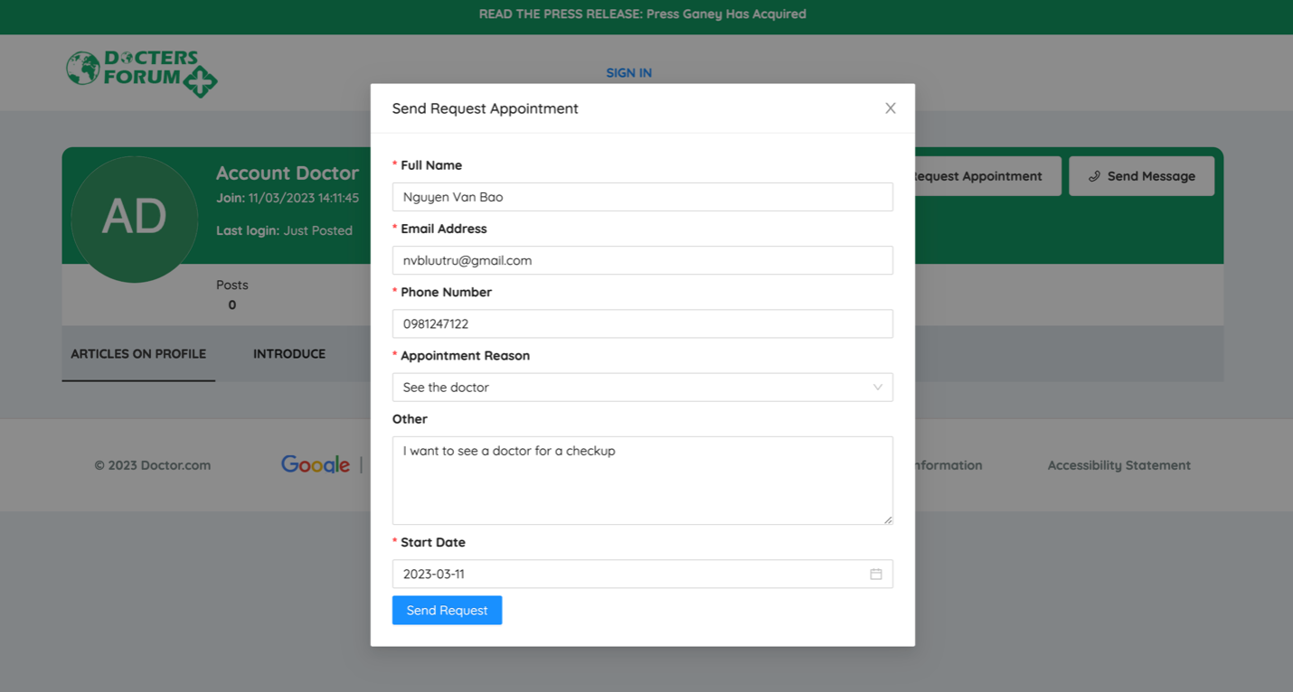

When an appointment is created, the doctor will receive the appointment via email

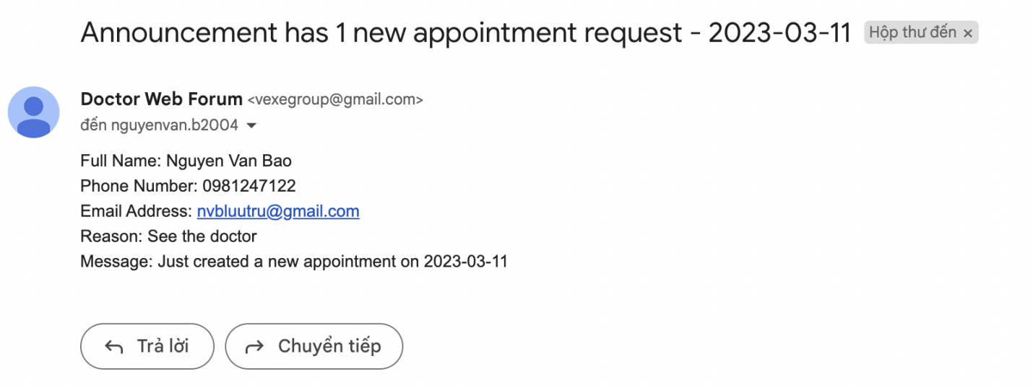

The doctor can manage appointments. 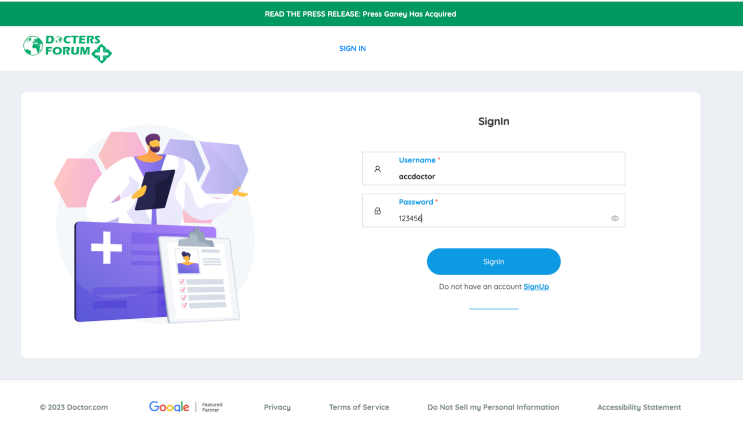

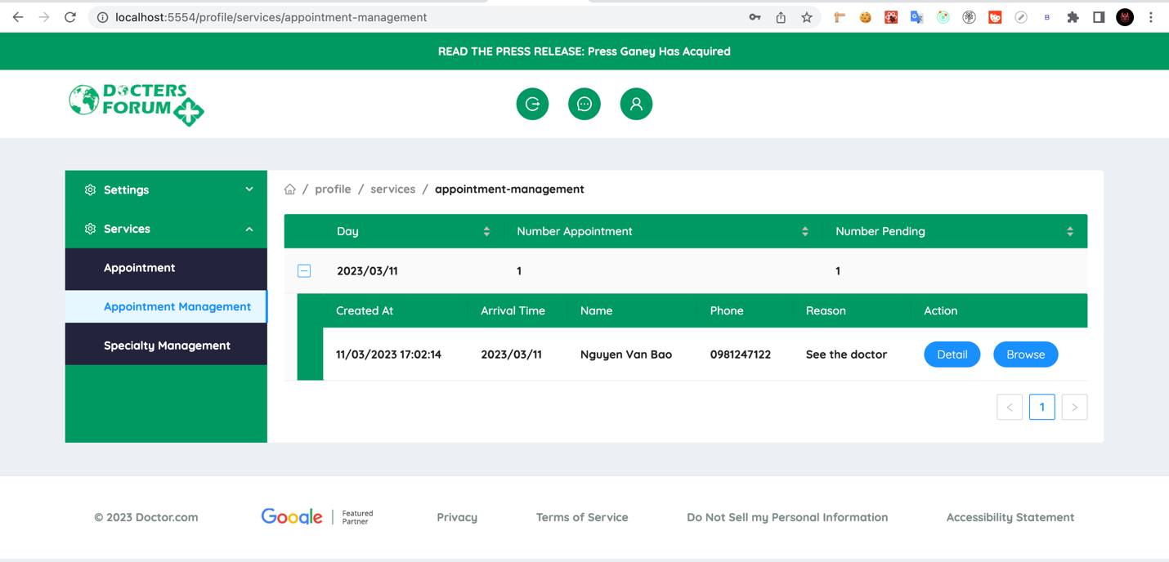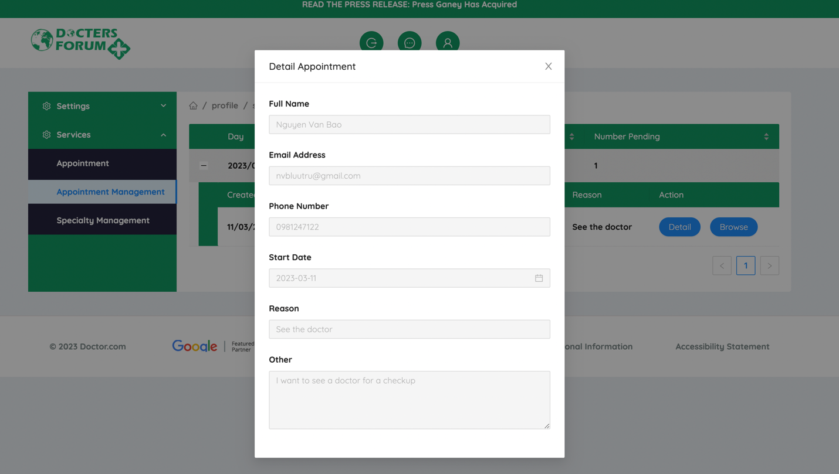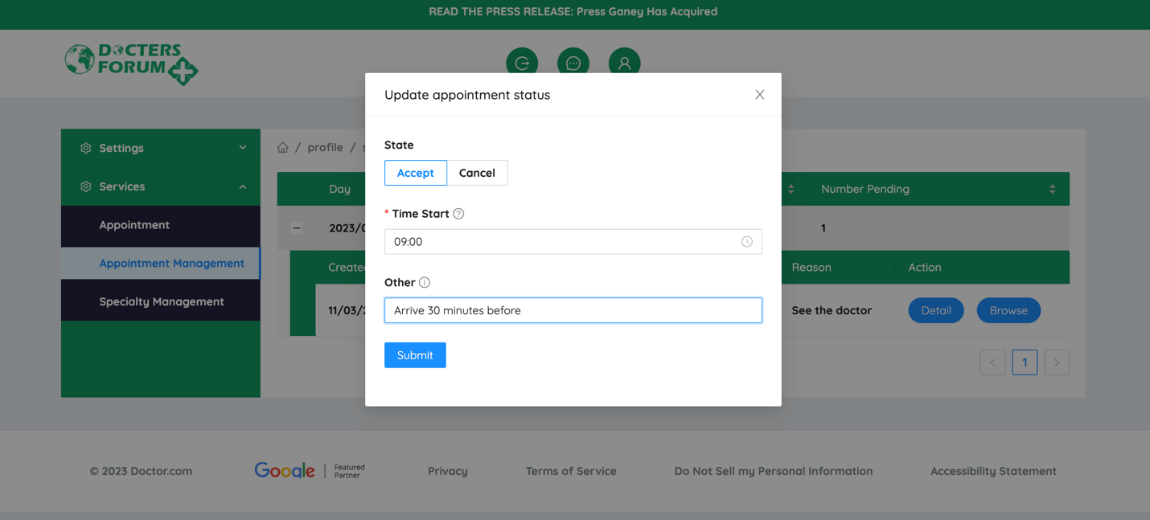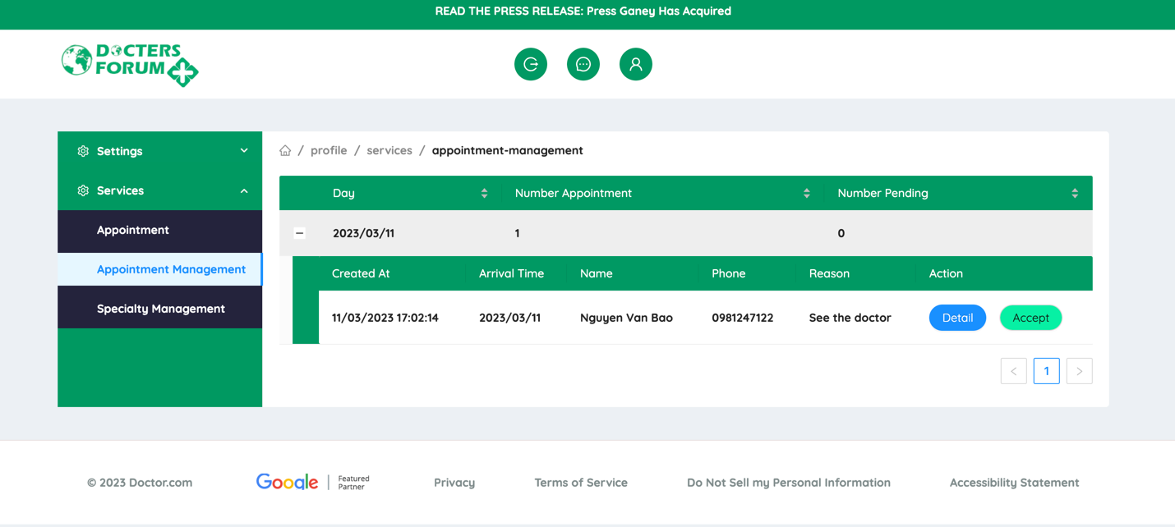

After accepting the appointment, the patient will receive an email with the start time, and the content of the email will depend on whether the doctor accepts or cancels the appointment.

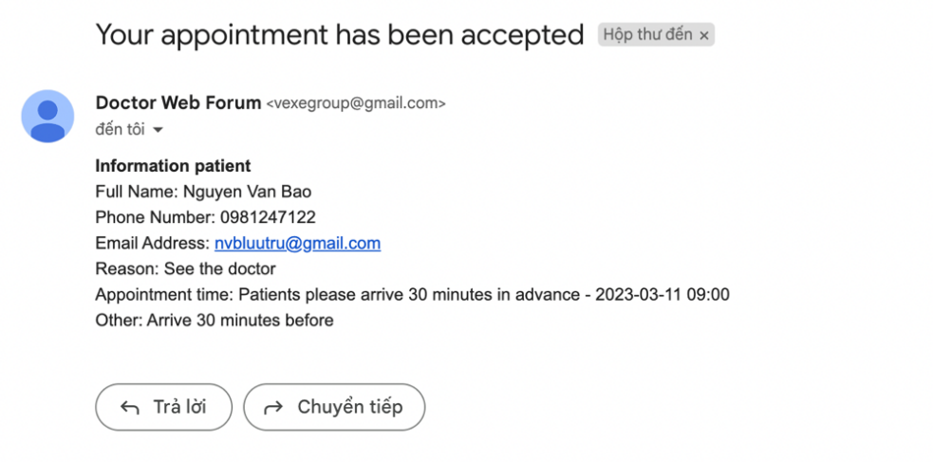

This page is used to configure appointments:

* It can limit the number of appointments per day.
* It can remind the user before the appointment starts.
* It manages the reason for the appointment displayed when the user creates an appointment.
* It manages the email receiving appointments. All listed emails will receive an email when a new appointment is created.

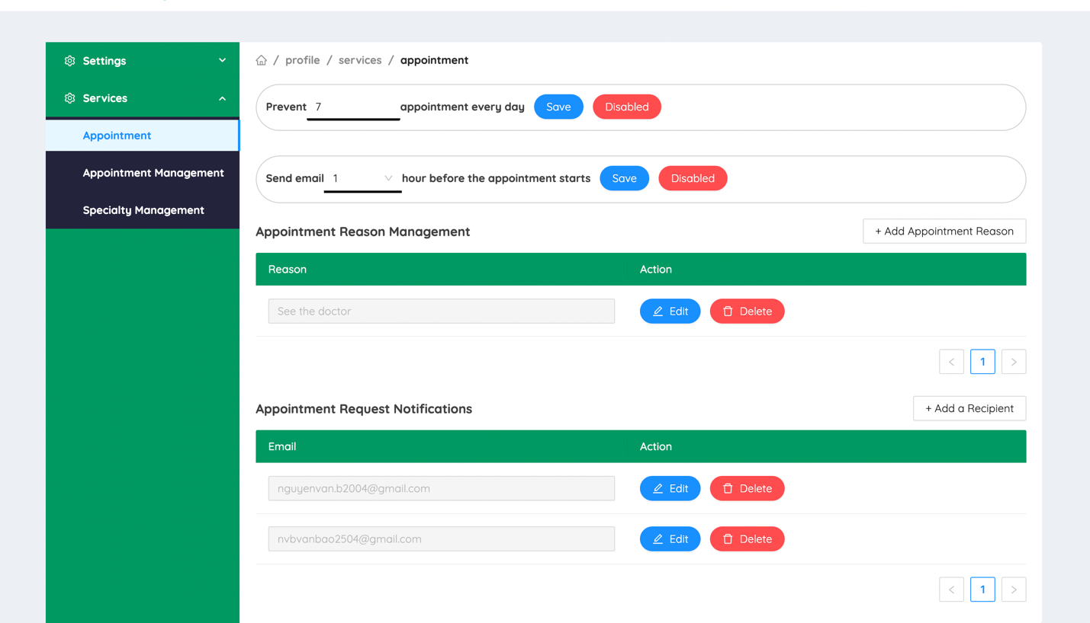

This page is used to manage and add the doctor's specialties.

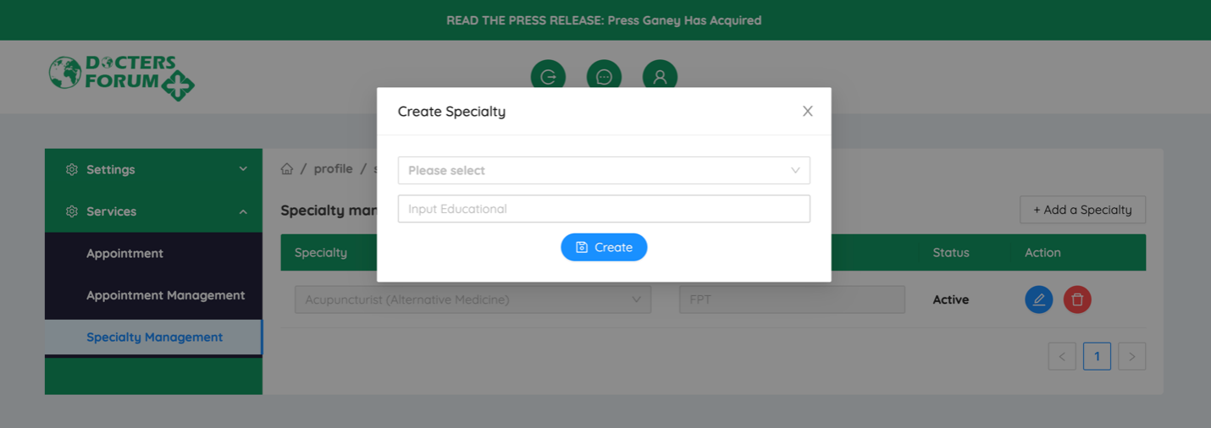

After adding a doctor, you need to send certification and related content via a Word file.

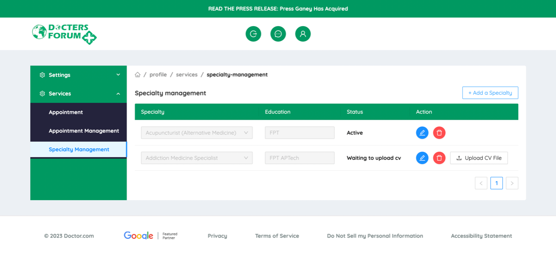

After the doctor sends the certification file, it needs to wait for the admin to approve the specialty before the patient can search for doctors by specialty.

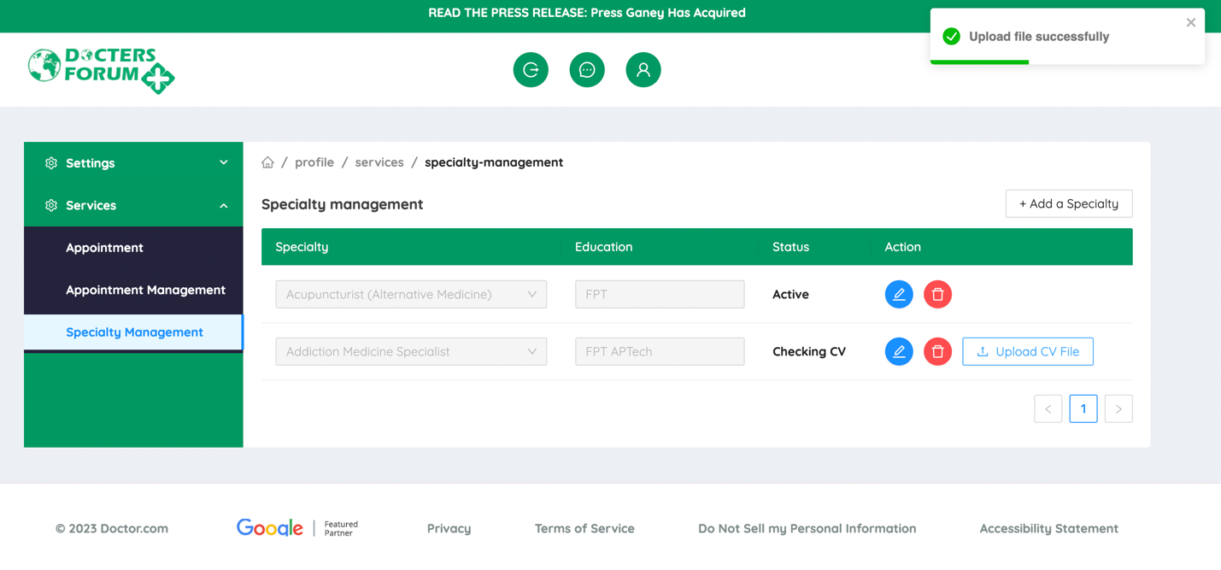

Admin management

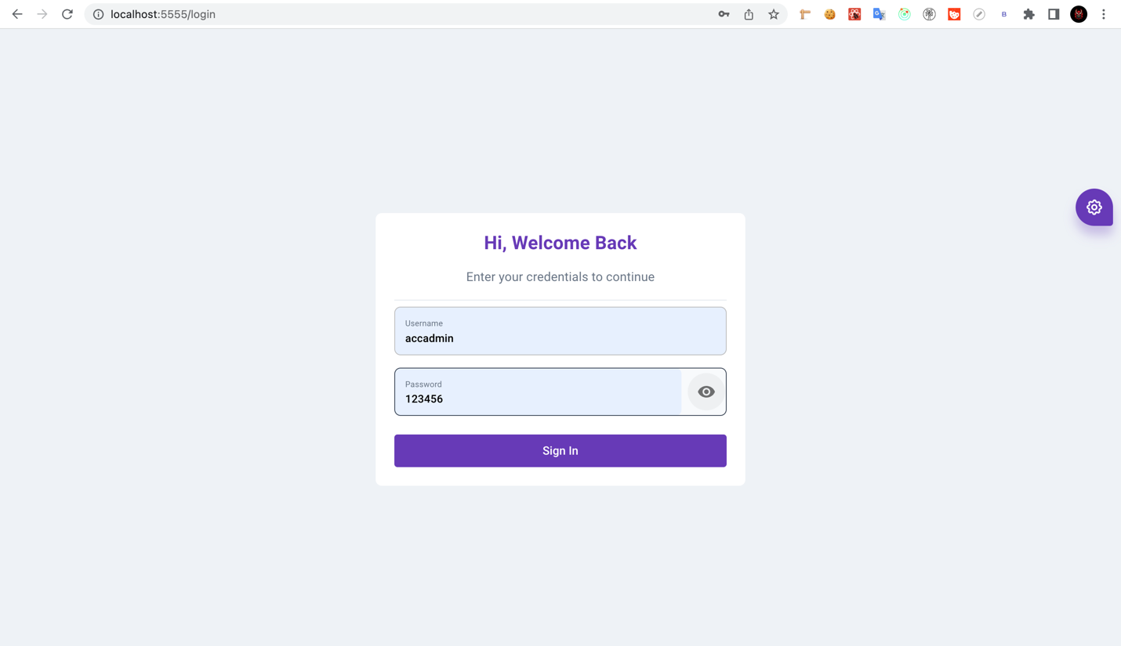

The column 'Specialty Checking' means that there is a certification file that needs

to be approved.

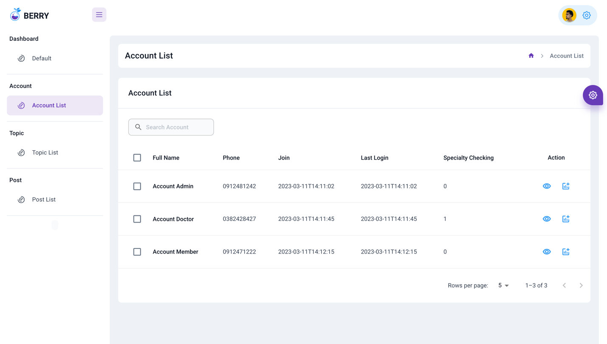

Click to display all specialties of the doctor.

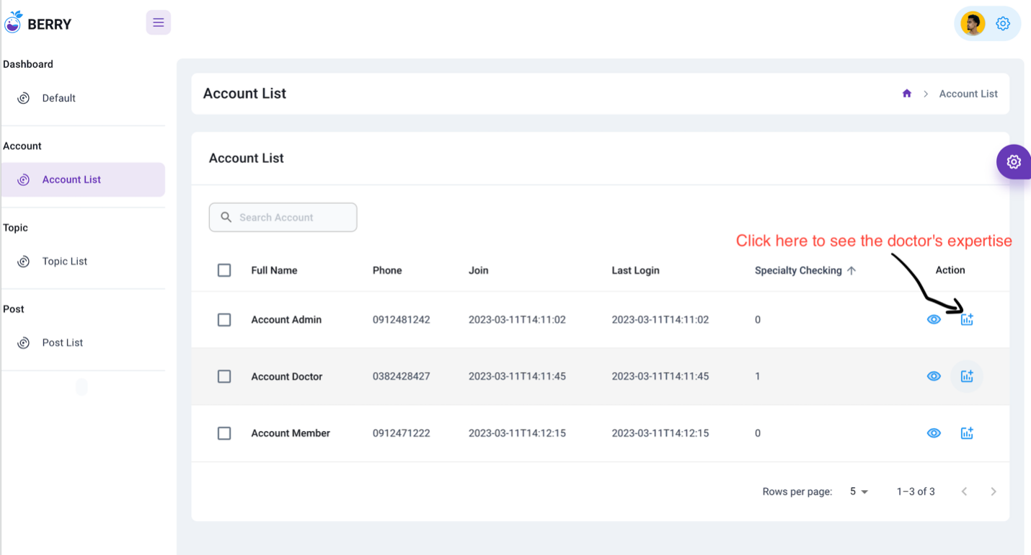

I will approve specialties with the status of "checking".

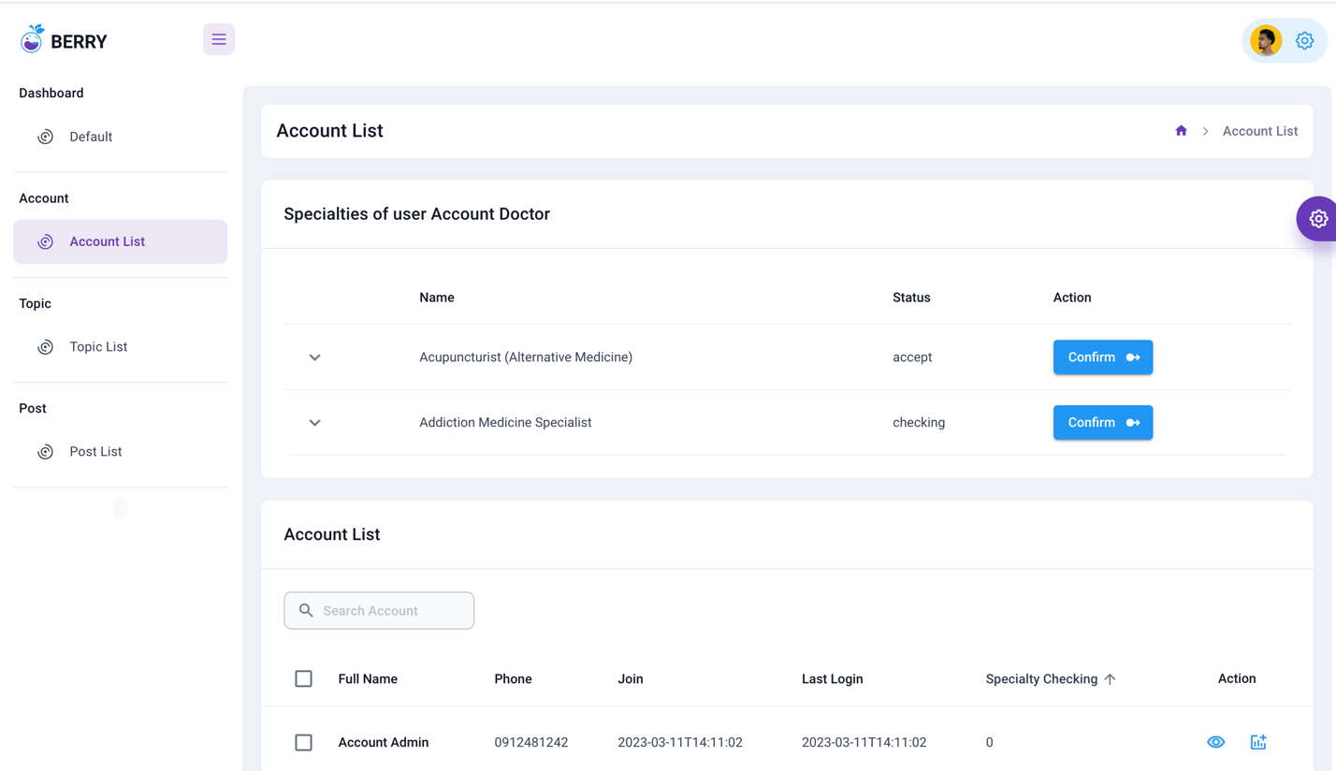

Before accepting, you need to read the certificate file that the doctor has uploaded.

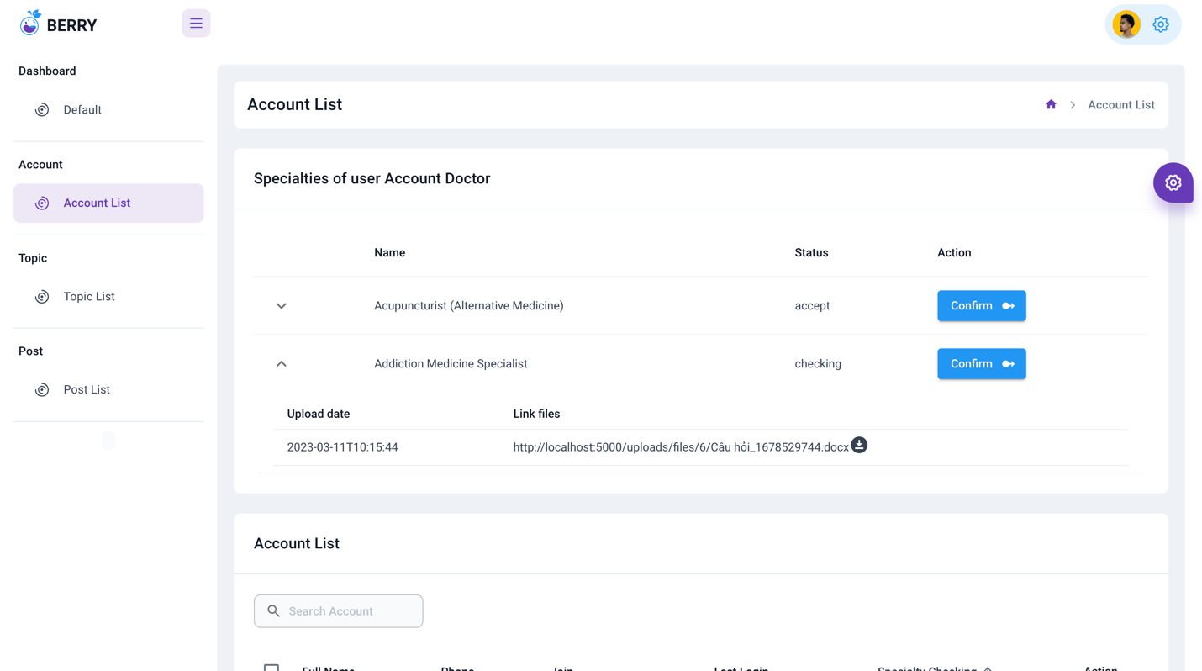

After reviewing the certificate file, you can update the status.

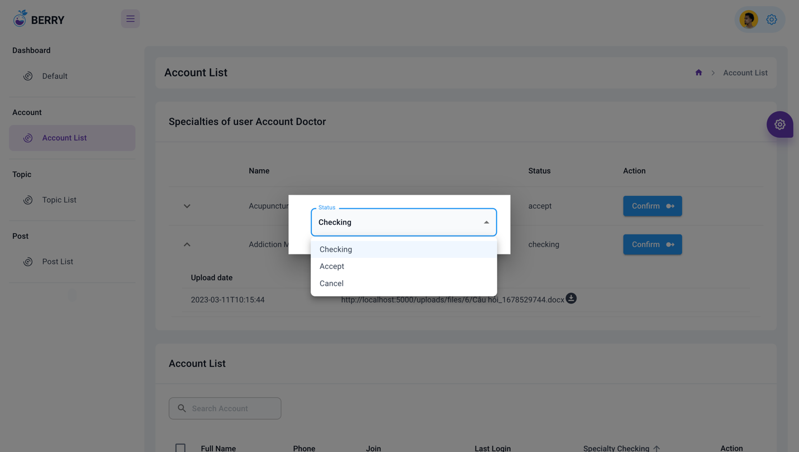

Update account information

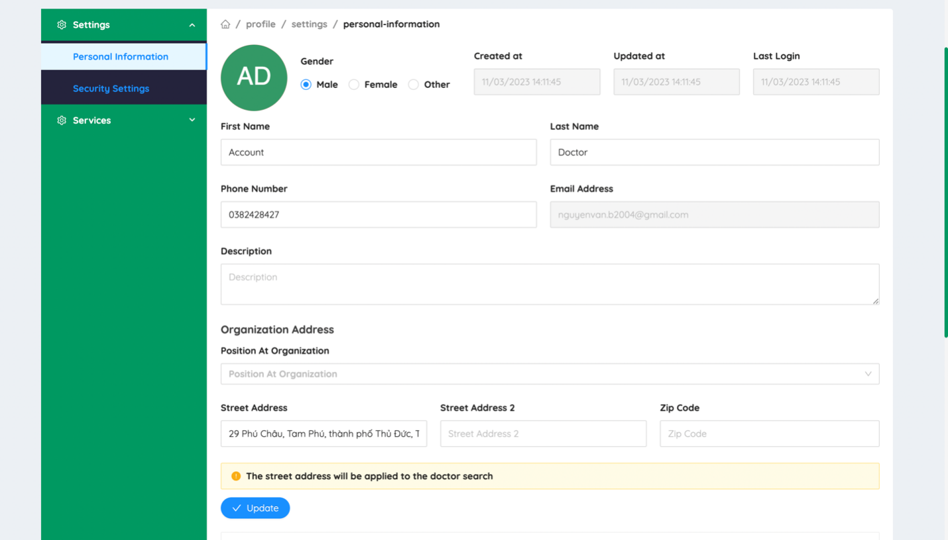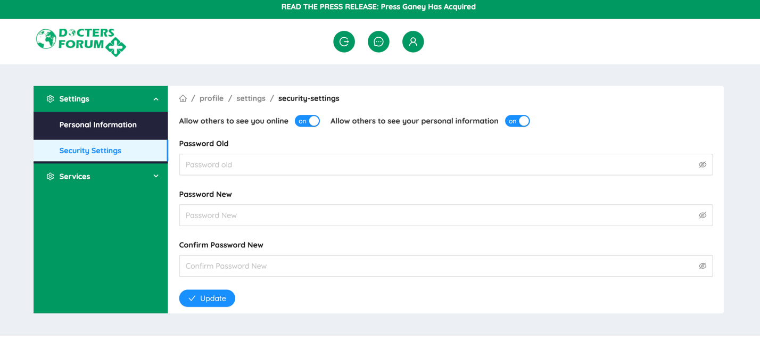

Real-time chat function with doctors

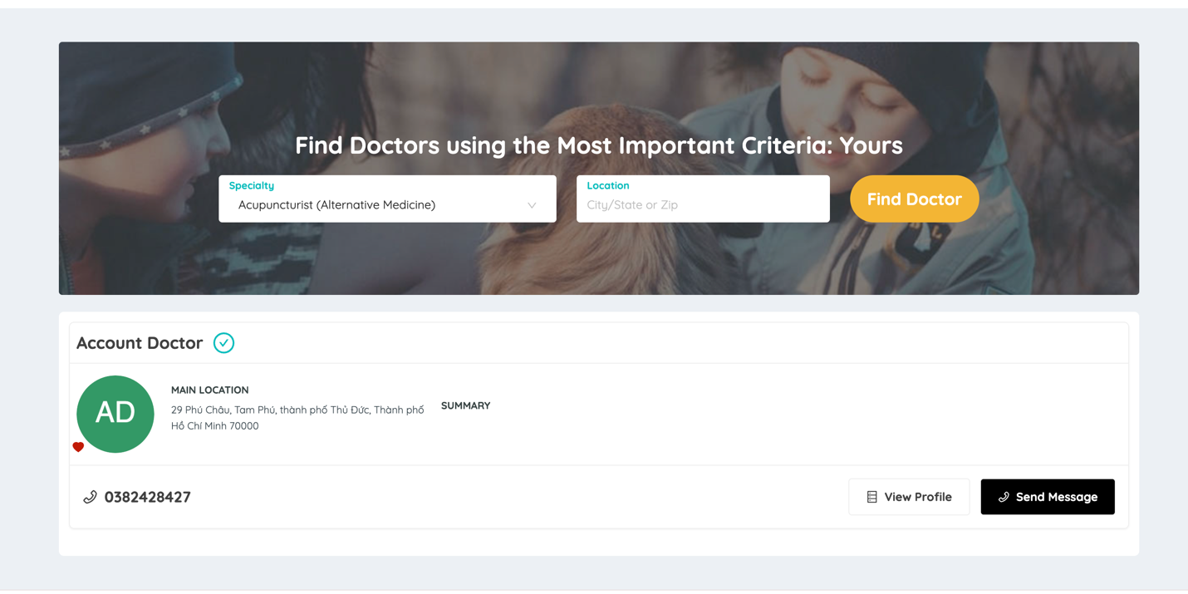

Login account member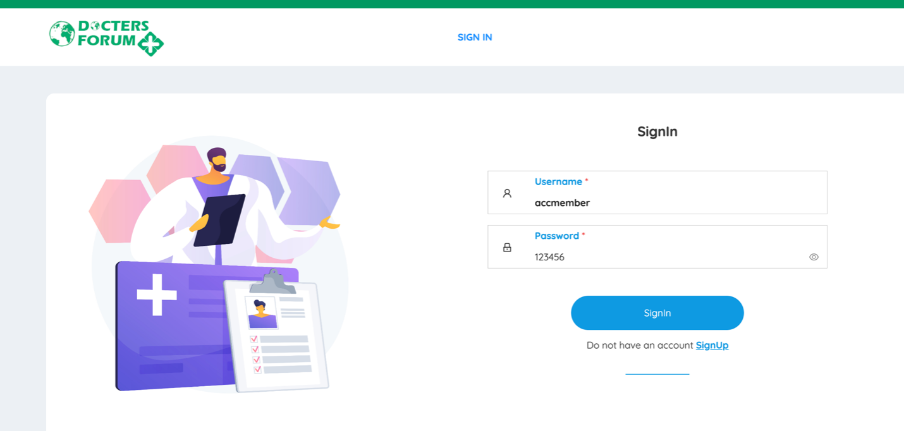

When texting the doctor, the doctor will receive the message immediately

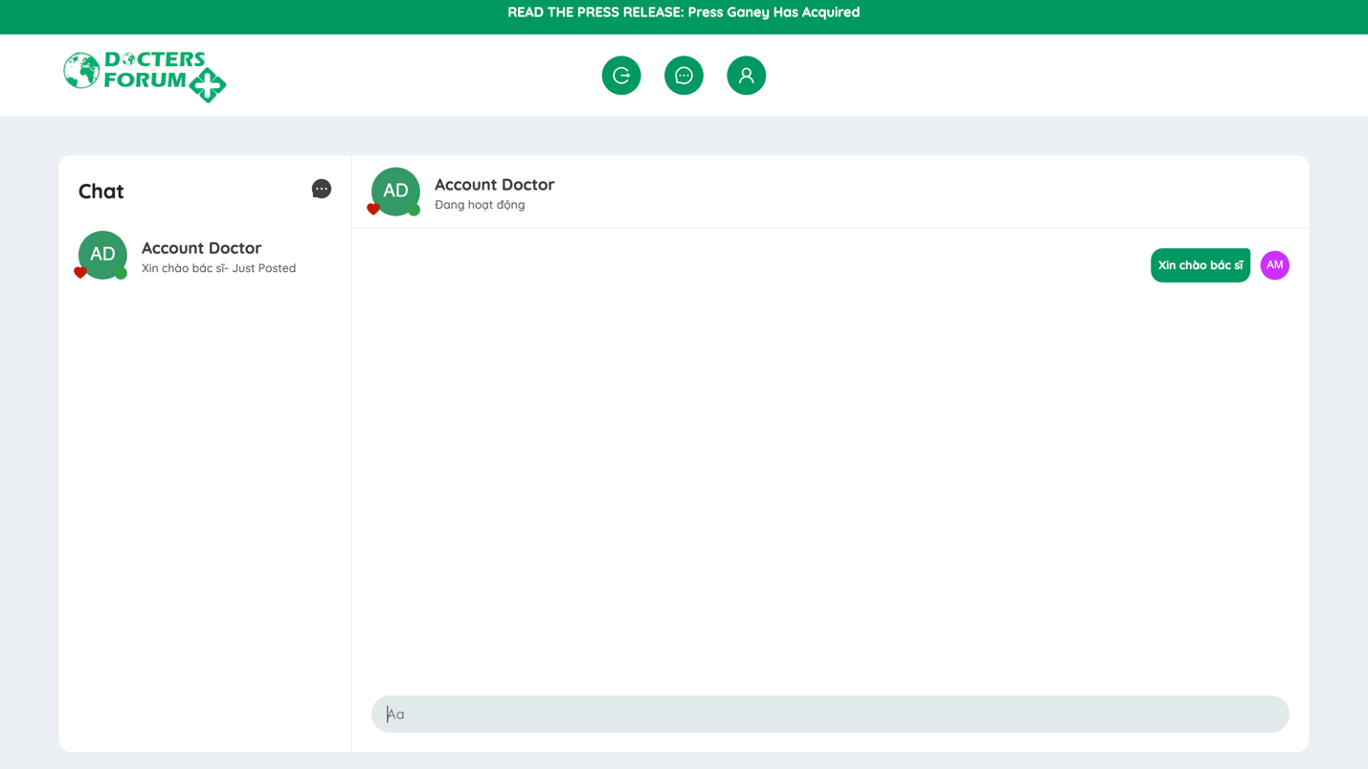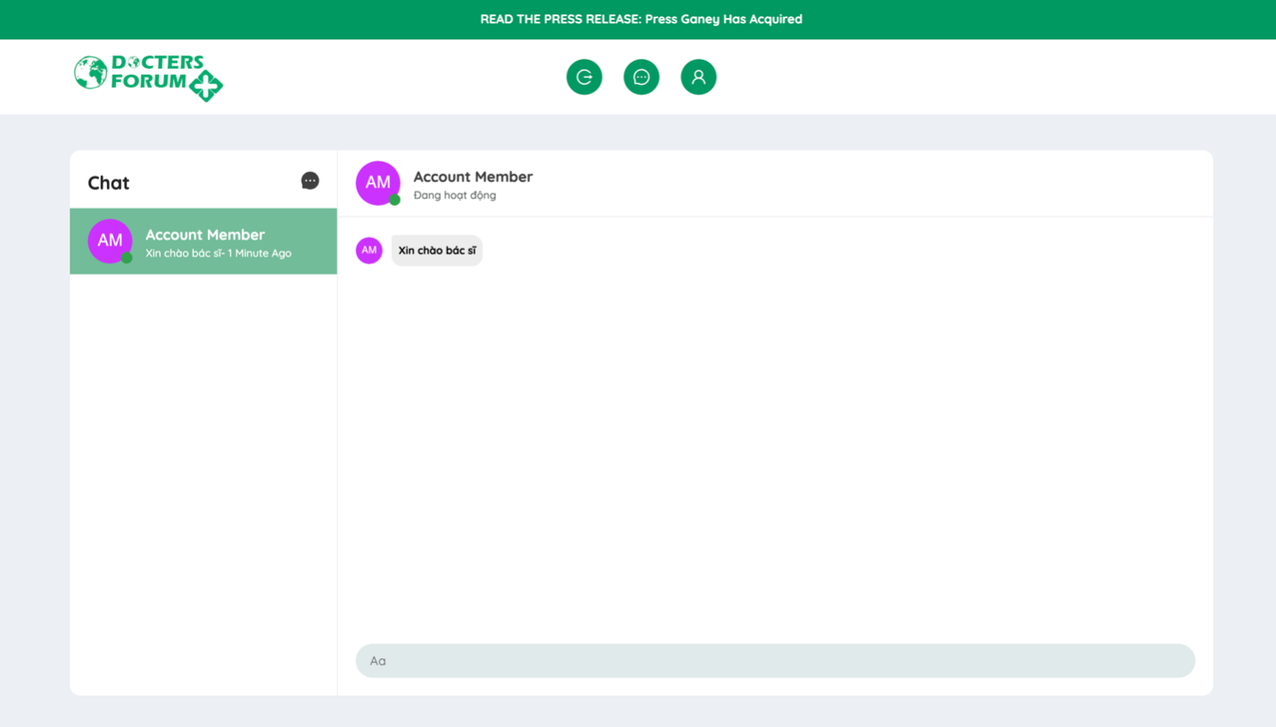

Guide to creating a post:

* You need to choose a topic to post, note that only doctors can post.
* For example, if you want to post in the "Charity Fund" topic, you need to click on "Charity Fund".

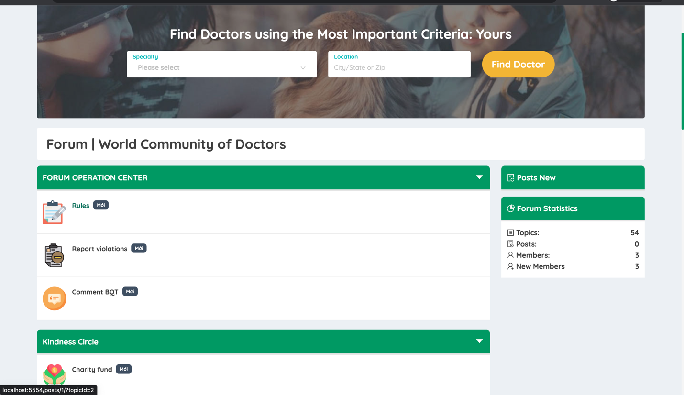

Enter the article content then press Create New Post

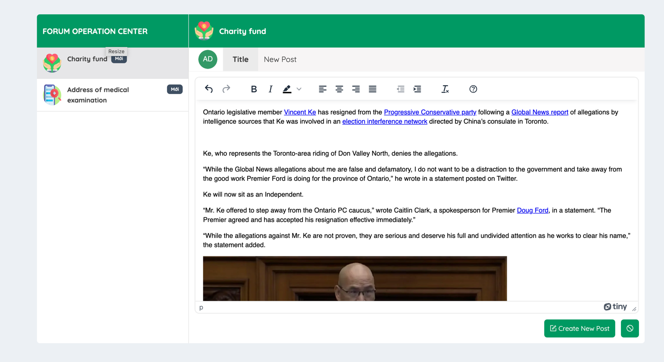

After creating a successful post you will see your post

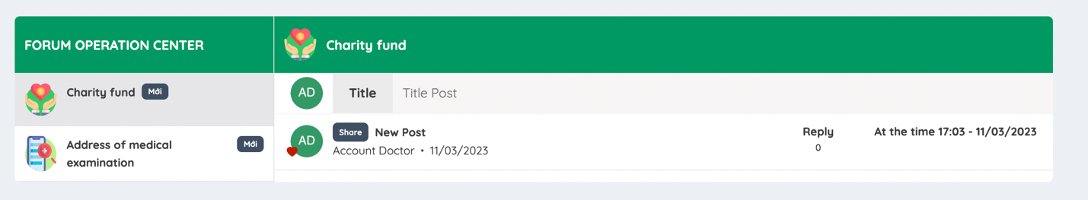

You can view the details of the post by clicking on the post title

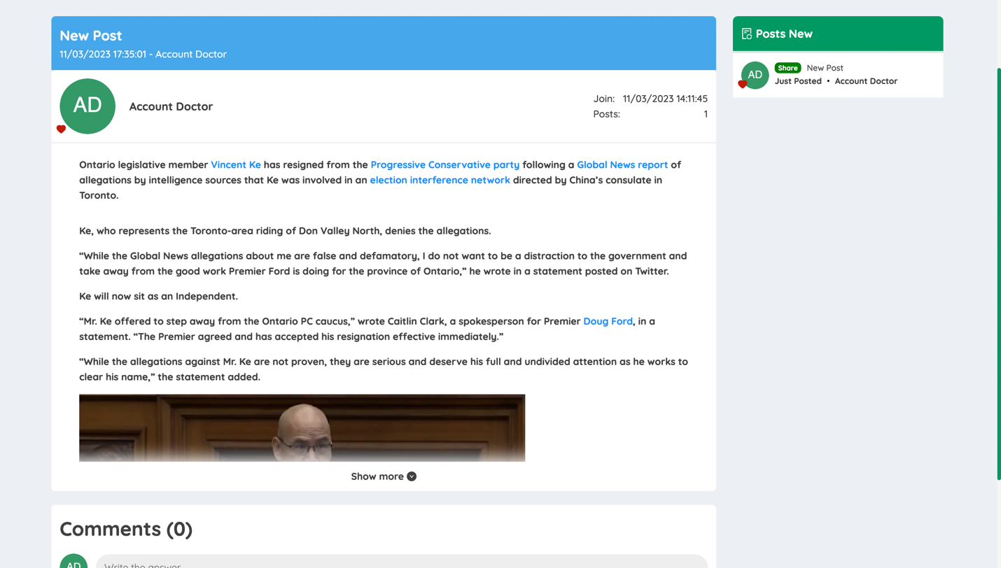

In the article details you can also comment or reply to other people's comments

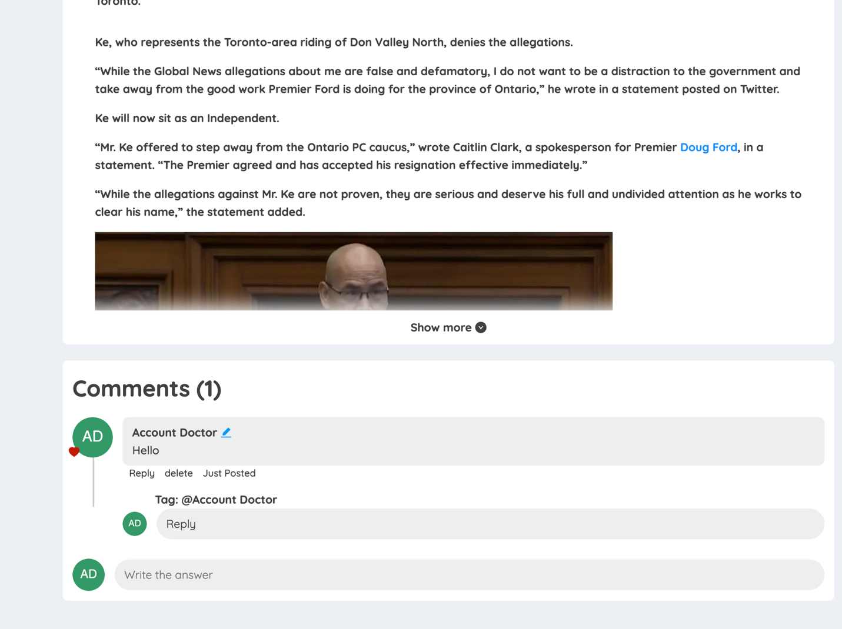

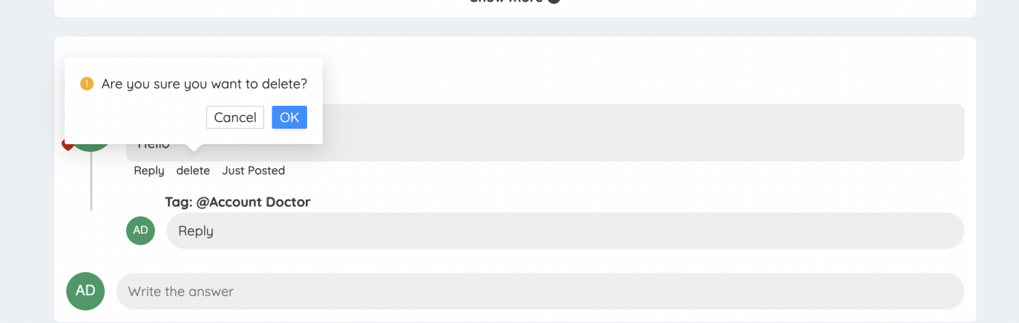

In the profile page will also display posts and can edit or delete

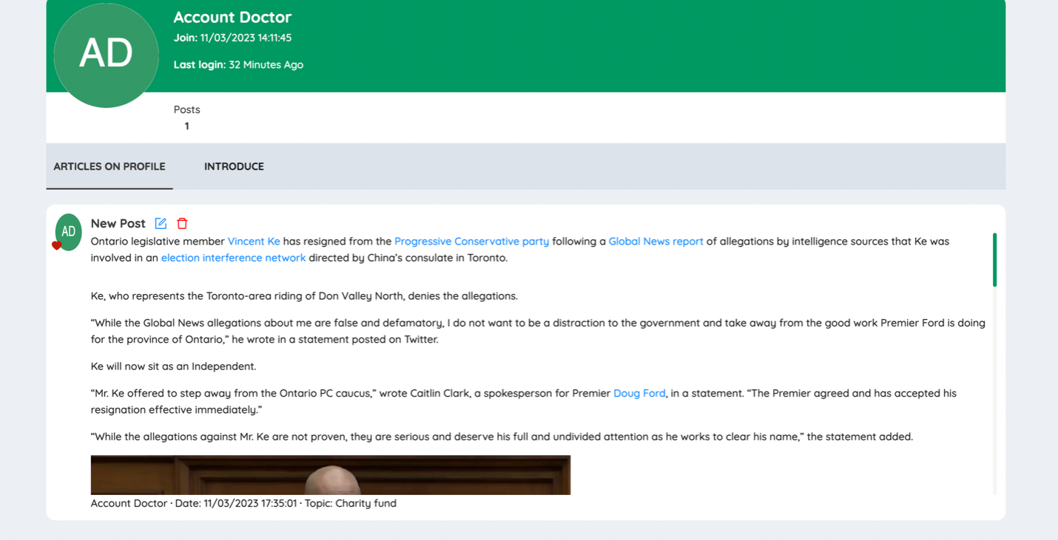

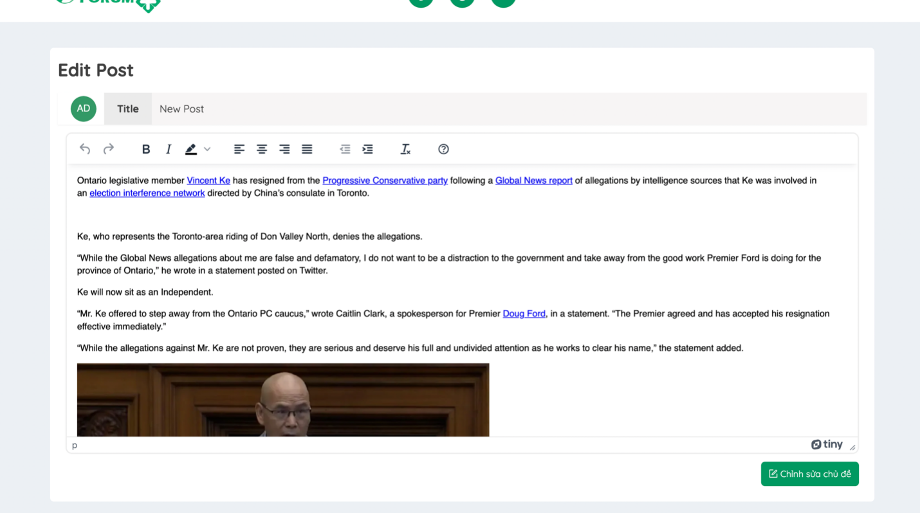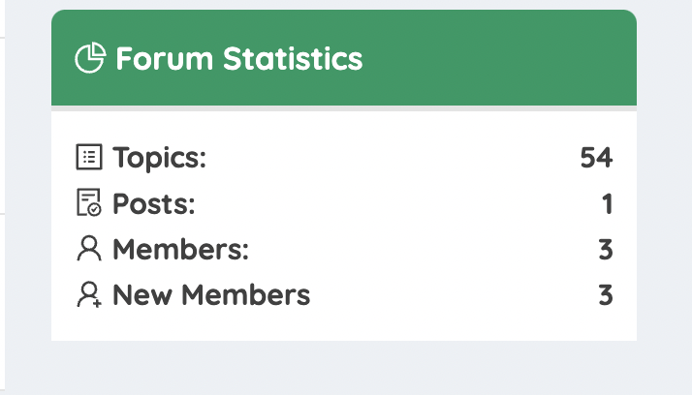

When users set the mode to not let others see personal information

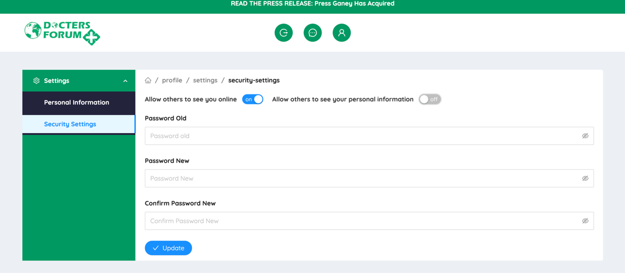

Instant user information. Will be hidden

